SYSTEM FLOW

1. LOGIN WITH USER ROLE – each role has different dashboard

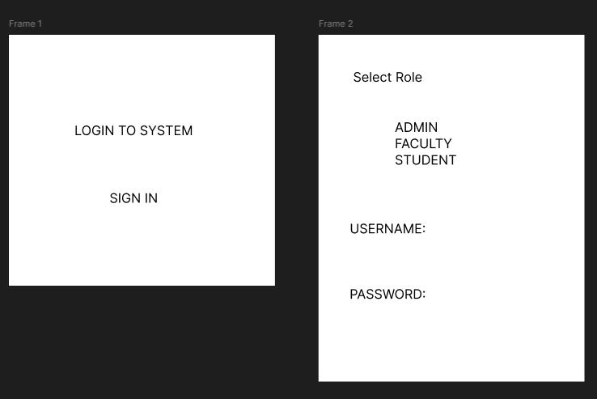

1. ADMIN DASHBOARD

Add Faculty (Name, subject, class, department, un and pw)

Faculty Directory/Monitoring (Faculty Details with assigned class and subject)

Tracking records of submitted grades

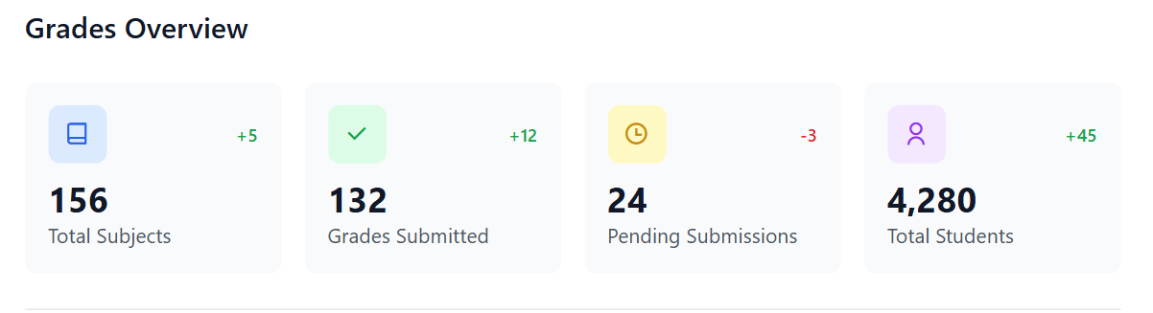

Report management (view all students, faculty and status of grades)

1. FACULTY DASHBOARD

Add student to their class/subject

Input grades for prelim, midterm, final and overall

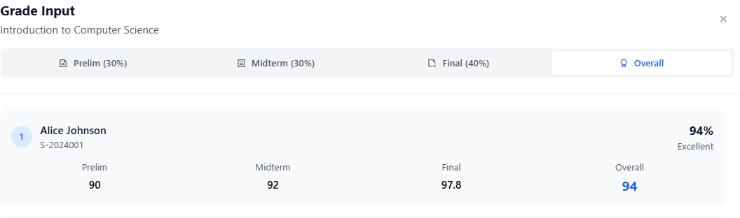

1. STUDENT DASHBOARD

Viewing of grades only

